TASK 4: HOW TO SIGN CERTIFICATES ON PUPPET MASTER

1 On Puppet master list the certificate list sudo /opt/puppetlabs/bin/puppetser ver ca list 2 Sign the slave certifcate sudo /opt/puppetlabs/bin/puppetser ver ca sign --all 3 List the certificates once again sudo /opt/puppetlabs/bin/puppetser ver ca list

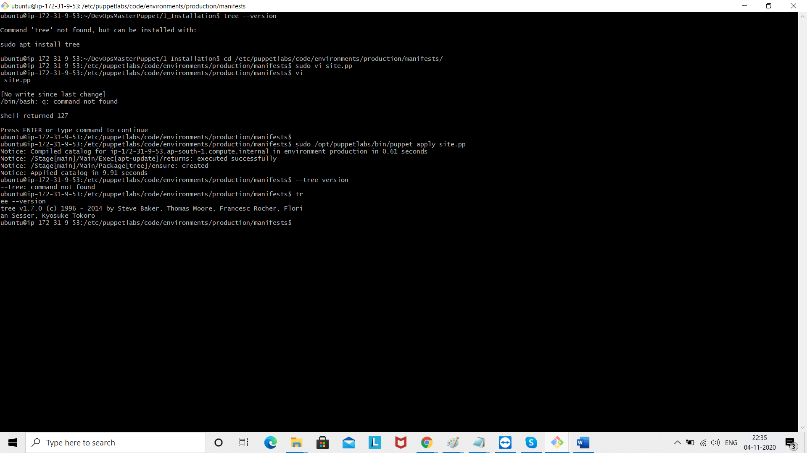

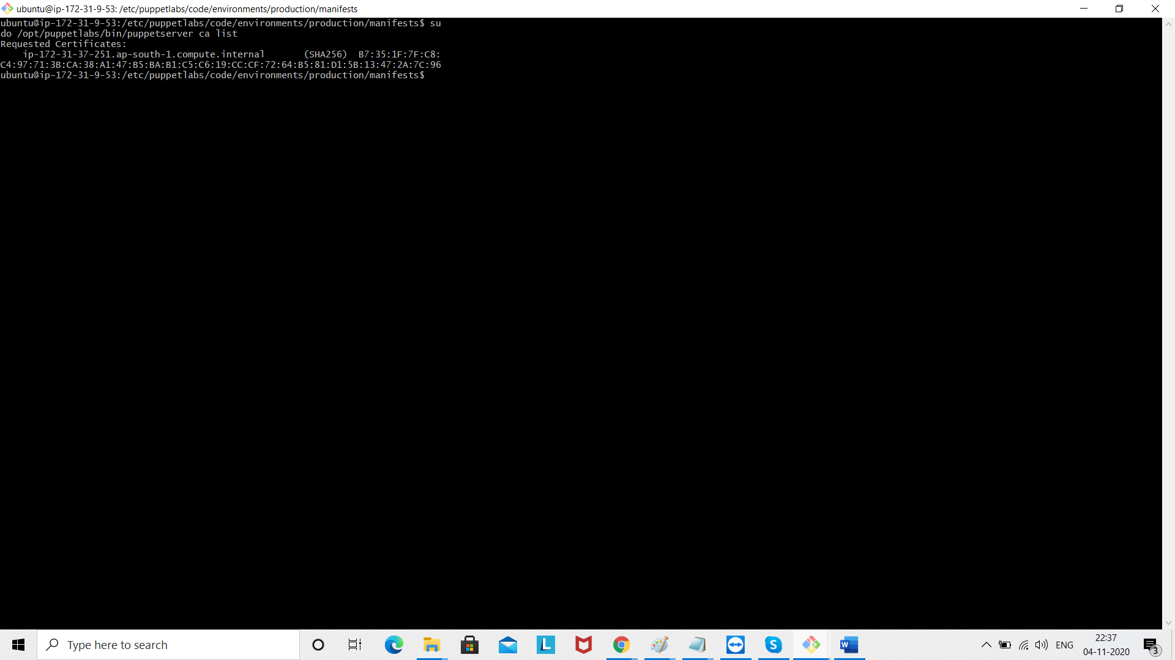

Sign the certificate

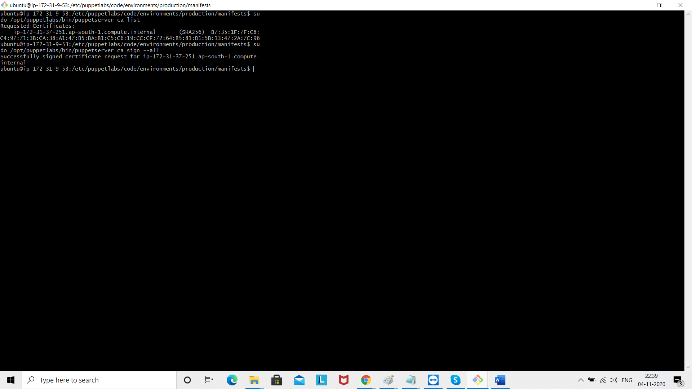

List the certificates once again

sudo /opt/puppetlabs/bin/puppetserver ca list

